Week 1 Experiment 2

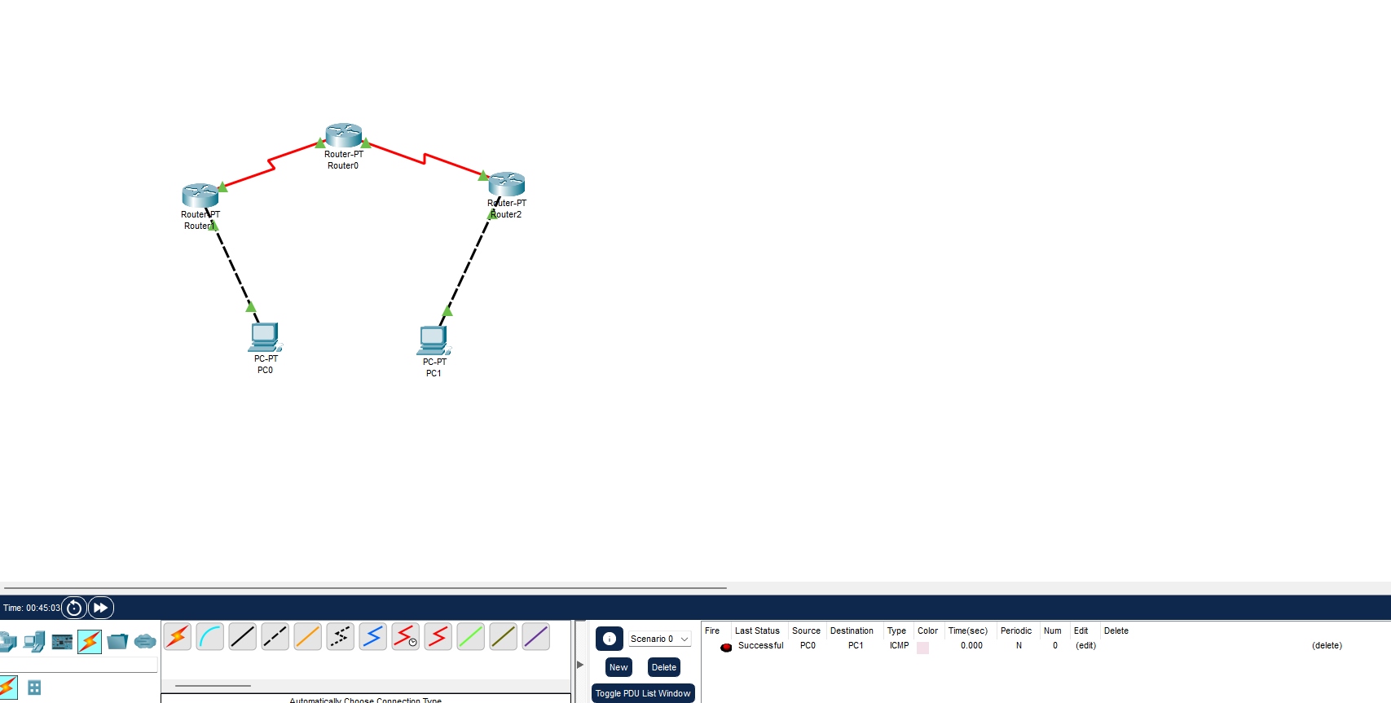
1. Reply
Normal configuration:
PC0> ping 40.0.0.10
Result:
Reply from 40.0.0.10
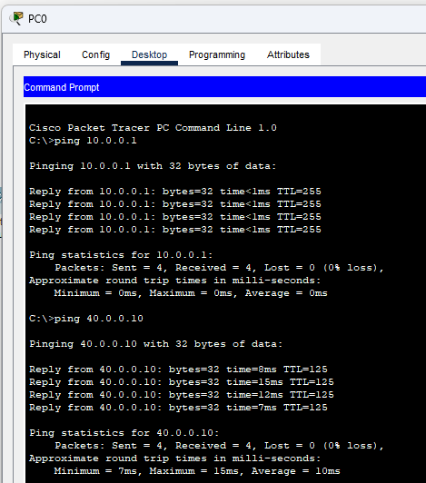

2. Request Timed Out
Temporarily disable R3's connection to PC1:
R3# configure terminal
R3(config)# interface fastEthernet 0/0
R3(config-if)# shutdown
Then:
PC0> ping 40.0.0.10
Observe the timeout/failure.
Restore afterward:
R3(config-if)# no shutdown
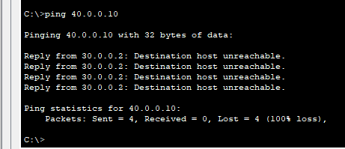

3. Destination Unreachable
Temporarily remove R1's route:
R1# configure terminal
R1(config)# no ip route 40.0.0.0 255.0.0.0 20.0.0.2
Then:
PC0> ping 40.0.0.10
Observe the unreachable/failure response.
Restore afterward:
R1(config)# ip route 40.0.0.0 255.0.0.0 20.0.0.2


